**Strategic Product Placement Analysis – A Visual Story**

This report presents a data-driven analysis of supermarket sales using Tableau dashboards, focusing on strategic product placement. It highlights key insights from sales patterns, customer behavior, and promotional effectiveness.

📅 **Project Duration:** 16 June – 30 June 2025

**Submitted by:**

* **K Akash Babu**
* **K Sowmya Sri**
* **K Chandrasekhar Reddy**
* **Jashuva Peddiboyina**

**Team ID:** LTVIP2025TMID51790

**Seshadri Rao Gudlavalleru Engineering College**

**Department of Information Technology**

1

# PROJECT OVERVIEW

In the competitive world of retail, where every inch of shelf space can influence customer choices, the importance of strategic product placement cannot be overstated. Supermarkets and retail chains often face the challenge of understanding which products perform best under certain conditions, how seasonal trends affect demand, and which customer segments respond more to promotions or layout changes.

Our project, **Strategic Product Placement Analysis**, dives deep into supermarket sales data using the power of Tableau data visualization. We created a range of interactive dashboards that help uncover hidden sales patterns, category-wise performance, and consumer preferences across different cities and demographics. The dashboards enable retailers to clearly identify underperforming areas and optimize shelf arrangements accordingly.

Through visual storytelling, we bring clarity to vast datasets and highlight the significance of visual analytics in shaping sales strategies. By understanding which products are most effective in certain store sections, at specific times, or for particular customer profiles, businesses can make smarter and faster decisions.

# PURPOSE

The purpose of this project is to analyze supermarket sales data and uncover meaningful patterns that support better product placement decisions. Using visual analytics, the goal is to present findings in a way that supports both business users and analysts in making informed choices.



# IDEATION PHASE

## Problem Statement

Supermarkets often struggle with product placement decisions due to a lack of data-driven insights.

Relying on assumptions can lead to poor shelf utilization and missed sales opportunities.

Our project addresses this by analyzing supermarket sales data to uncover meaningful trends. The goal is to support smarter product arrangements based on customer behavior, location, and promotions.

### 📄 View PDF [–](https://drive.google.com/open?id=1QpllqyLEXhLPTlIHKcDWnKAr_GTr3klq) [Problem Statement](https://drive.google.com/file/d/1RXu15Nr9tOeeT6JaQ9_1h1A_5ThAo2mO/view?usp=drive_link)

## Empathy Map Canvas

To understand retail managers' real challenges, we created an Empathy Map.

It helped us capture what they see, think, feel, and do while planning product layouts.

This human-centered view aligned our dashboard design with user needs.

It ensured our analysis focused on data that truly matters to decision-makers.

### 📄 View PDF [–](https://drive.google.com/open?id=19O14idZ72x6ntSqFIrGAn0U0Xgpkqa8L) [Empathy map](https://drive.google.com/file/d/1wHKlr82g7v8SUt_ZMuZn5PQWcRggEuYY/view?usp=drive_link)

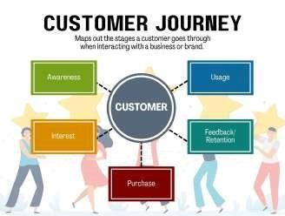

**REQUIREMENT ANALYSIS**

**Customer Journey Map**

The

**Customer Journey Map**

outlines the step

-

by

-

step experience of a retail

shopper

—

from entering the store to completing a purchase. It highlights key

touchpoints, emotions, and behaviors that influence buying decisions.

By

visualizing this journey, we aligned our dashboard design with real customer needs and

pain points.

## BrainStorming

Our team conducted a brainstorming session to identify key areas of focus for the project.

We discussed potential challenges in product placement and how data could solve them. This helped us finalize important metrics like city-wise sales, category performance, and promotion impact. The session guided the structure and goals of our Tableau dashboards.

📄 **View PDF** [**–**](https://drive.google.com/open?id=116K84BZ_HygneAIdd9rYBt7FuIqs9y_b) [Brainstorming](https://drive.google.com/file/d/1uhbuK3vrZW3hPu-nBD60ifdNEiZl731G/view?usp=drive_link)

## Solution Requirement

The **solution requirements** are categorized into **functional** and **nonfunctional** needs.

Functional needs include dashboards, filters, and KPI-based insights.

Non-functional needs focus on performance, user-friendliness, and visual clarity.

Together, they ensure the solution works well and is easy to use for everyone.

### Data Flow Diagram

The **Data Flow Diagram (DFD)** shows how data moves through our project system.

It maps the flow from raw sales input to processing and visualization in Tableau.

This helps us understand how each component connects and supports the final output. It ensures clarity in data handling and smooth dashboard generation.

### Technology Stack

Our project uses a combination of tools for analysis, design, and reporting.

Tableau is used for creating dashboards and data visualizations. Google Docs and Canva support documentation and design.

GitHub is used for organizing project files and collaboration.

# PROJECT DESIGN

The project design defines the overall flow from data input to visual output. It starts with importing and understanding supermarket sales data, followed by identifying key metrics like sales, profit, and category-wise performance. Calculated fields and filters are integrated to make the dashboards interactive and insightful. The final visualizations are crafted in Tableau to ensure clarity, usability, and support for smart decision-making.

## Problem Solution Fit Solution Architecture Proposed Solution

Retail stores often place products The solution architecture outlines Our solution uses tableau based on assumptions rather end-to-end flow from raw data to dashboard to analyze than data.Our project addresses final Visualization. It begins with supermarket sales and this by using real sales data to guide importing supermarket sales data product placement. It product placement.Tableau into Tableau, followed by defining includes filters, KPI’s, and

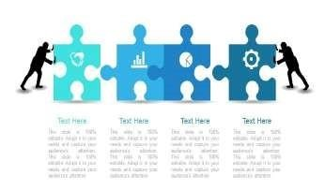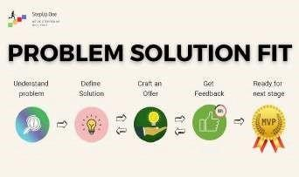

dashboards provide calculated fields, filters, and KPI’s. Visual charts to highlight visuals that support informed These components feed into key trends. This helps

decisions.This ensures alignment dashboards and a story to deliver retailers make informed between business problems and the actionable insights. The structure placement and promotion solution offered. ensure smooth data processing. decisions.

# PROJECT PLANNING & SCHEDULING

## Project Planning

The project was planned using Agile methodology, broken down into two 5-day sprints. Each sprint focused on specific deliverables, including data analysis, dashboard creation, testing, and documentation. User stories were created for each functional task and prioritized based on business value and complexity.

## 📅 Week 1: 16–18 June

* Project topic finalization
* Team role assignment
* Requirement gathering
* Data set selection and exploration

## 📅 Week 2: 19–21 June

* Data visualization planning
* Created empathy map, journey map, and DFD
* Designed initial dashboards in Tableau
* Defined KPIs and calculated fields

## 📅 Week 3: 22–23 June

* Completed final dashboards and Tableau story
* Applied filters and tested interactivity
* Reviewed user feedback and made improvements

## 📅 Week 4: 24–25 June

* Performed testing and documentation
* Finalized report and visual assets
* Reviewed user feedback and made improvements

# FUNCTIONAL AND PERFORMANCE TESTING

To ensure our dashboards were effective and user-friendly, we conducted basic functional and performance testing. The goal was to confirm that all interactive elements worked correctly and that the dashboards performed smoothly when published online.

## Functional Testing Performance Testing

Functionally, the dashboards From a performance perspective, all dashboards responded accurately to dynamic loaded quickly and handled interactions with filters such as City, Gender, and Product zero lag, while story transitions and hover effect Line, and the calculated KPIs like Total remained smooth and responsive throughout. Profit and Promotion Impact returned consistent, correct values.

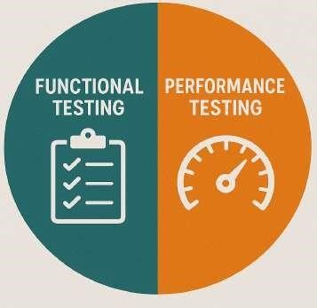

✅ Filters respond ⚡Dashboard load time on Correctly (Consumer different internet speed

demographics,Product (under 3 seconds on broad category, Position). band).

✅ All charts update input 📱 Responsiveness across

Dynamically based on desktop and mobile

Filter input. browsers.

✅ Tooltips display accurate Values for each 🔍Data consistency -Verified no null values data point.

or mis matches post-processing

✅Tableau story navigates smoothly between 🌐Publishing stability - Dashboards

Different insights remained fully interactive on Tableau public.

.

✅Calculated fields like sales volume and 🧩Smooth filter transitions - Dashboard price difference etc impact display accurate handled multiple filter combinations results across all visualizations. Without any lag or visual glitches.

# RESULT

This interactive Tableau dashboard provides a comprehensive view of supermarket sales performance based on **shelf position, product category, and promotional strategies**. Key metrics like Total Sales, Average Price, and % of Overpriced Products are prominently highlighted. Visuals such as bar charts, heatmaps, donut charts, and bubble diagrams reveal patterns in foot traffic, sales distribution, and pricing comparison with competitors. Filters for demographics, product position, and promotion allow users to explore tailored insights for strategic product placement decisions.

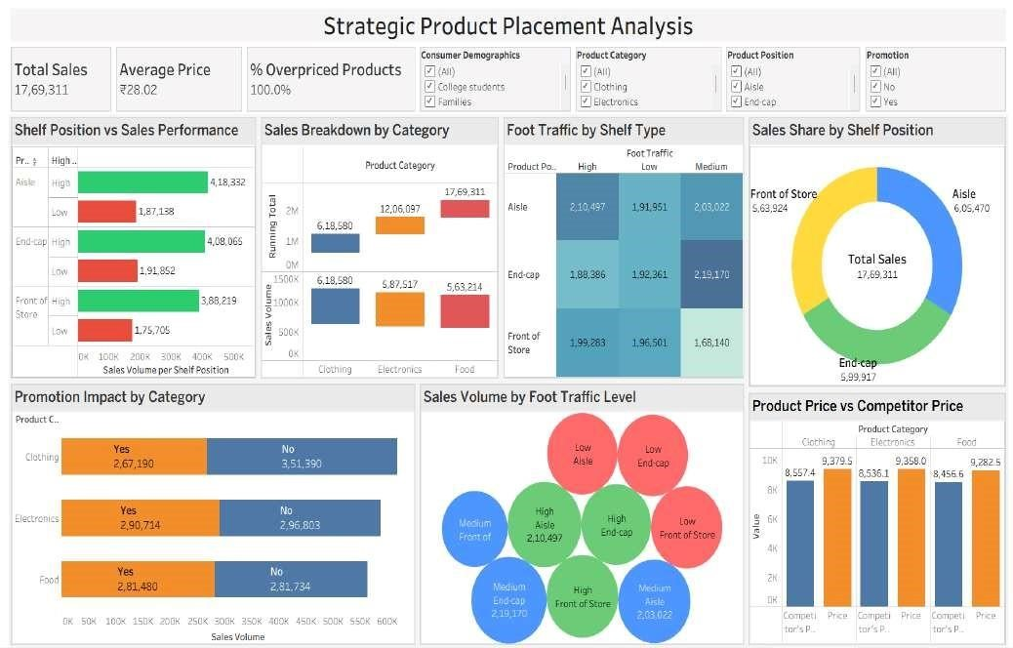

**Figure:** Strategic Product Placement Dashboard showcasing sales performance, foot traffic, and promotion impact across shelf types.

# ADVANTAGES & DISADVANTAGES

## 🟢Sales Psychology Unlocked

**→** Reveals how shelf placement subtly guides consumer decisions, helping businesses leverage behavioral patterns.

## 🟢Visual ROI Triggers

**→** Instantly connects sales impact to placement and promotion efforts, a visual return-on-investment tool for marketers.

## 🟢Eliminates Guesswork

**→** No more trial-and-error managers can test assumptions using interactive filters and KPI shifts in real time.

## 🟢Cross-Category Insight Bridging

**→** Clothing, electronics, food — all visualized in parallel to detect where

promotions really work and where they fail.

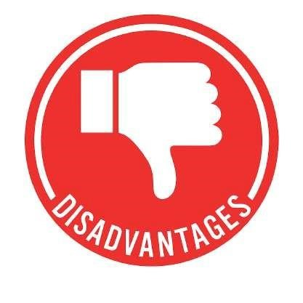

## 🔴 Limited Predictive Capability

**→** The dashboard shows past trends but doesn’t forecast future placement outcomes.

🔴 **Static Dataset Dependency**

**→** Insights rely on preloaded data real-time updates are not integrated*.*

## 🔴 Device Compatibility Gaps

**→** Some dashboard elements may appear misaligned on smaller mobile screens.

## 🔴 Lack of Automation

**→** Does not auto-suggest placement improvements require manual exploration.

# CONCLUSION

## 📊 Data-Driven Insights

This project showcased how Tableau can transform raw sales data into clear, actionable insights that enhance product placement strategies.

## 🛠 User-Friendly Dashboard

Our interactive dashboards made it easy for both technical and non-technical users to explore trends using filters, KPIs, and visual storytelling.

## 💡 Smarter Product Decisions

By analyzing sales, demographics, and promotional impacts, we empowered retailers to make informed shelf placement and marketing decisions.

## 🚀 Ready for Future Expansion

The project lays the foundation for real-time analytics, integration with POS systems, and further scalability across different retail segment.

# 🔮FUTURE SCOPE

## 📈 AI-Driven Sales Forecasting

Integrate machine learning to predict future sales based on historical trends.

## 🧠 Personalized Product Placement

Use customer behavior data to auto-suggest product layouts per region or demographic.

📊 **Real-Time Dashboard Updates**

Connect with live sales data for dynamic, always-updated visual insights.

🔄 **Cross-Store Comparative Analysis**

Compare performance between different store branches for optimized placement.

## APPENDIX

The appendix serves as a curated collection of all essential project assets — from interactive dashboards and cleaned datasets to sprint plans and documentation tools. It acts as a behind-the-scenes lens into how data transformed into decisions, offering transparency and traceability for every insight delivered.This section contains supporting materials, resources, and important links related to the project **“Strategic Product Placement Analysis – A Visual Story”.**

### 🛠 Tools & Technologies Used

**Tableau –** Data visualization and interactive dashboards

**Google docs –** Data preprocessing and formatting

**Github –** Folder organization and version control

**Mural –** Brainstorming,planning diagram (e.g.,empathy map,solution canvas)

### 📂 Dataset used

We utilized a real-world dataset sourced from Kaggle and further refined it to meet the specific requirements of our visualization goals. Below are both versions for reference: **Original Dataset –** Raw data directly from Kaggle, includes product sales,customer info and more.

[🔗 **View original**](https://drive.google.com/open?id=1uP_VuKNES52XoFRlKR5oe2EM2PGlEnUx)

**Updated Dataset –** Cleaned and preprocessed version used in Tableau; includes added

Added columns like sales volume, price difference etc.

[🔗 **View updated**](https://drive.google.com/open?id=12srmMlds1QMWiWQMYdSxbLaukL2H-RD8)

🔗**Demo & Dashboard Access:**

[📊 **Tableau Public**](https://public.tableau.com/app/profile/som.sampreeth.rokkam/viz/project_17506829417280/FinalDashboard?publish=yes) [**Dashboar**](https://public.tableau.com/app/profile/akash.babu.kalapala/vizzes)[**d**](https://public.tableau.com/app/profile/som.sampreeth.rokkam/viz/project_17506829417280/FinalDashboard?publish=yes)